If you are adding new material for a new library that does not yet exist on SoundDogs.com: advise SoundDogs.com by email so a new library can be created for the new material. You will not be able to proceed until a place for the new library has been created on our server. SoundDogs.com will email you when the new library has been added.
Adding new material to an existing library (including one that has just been created as above):
STEP ONE:
Log in to SoundDogs.com with your publisher logins. In the upper navigation bar you will see a link to upload your material: If you do not have publisher logins, contact us.
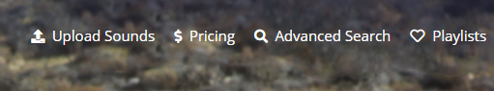
STEP TWO:
This screen will open:
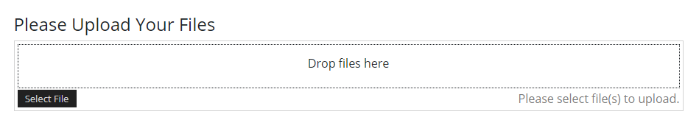
Use the “Select File” button to navigate to where you keep your source files. Choose the files to upload. There is a limit of 100 files that you can upload at a time but you can repeat the process of uploading 100 files several times before you proceed with the next steps. Upload the first 100. You can repeat the process but there is a timeout possibility if you select too many for one session. We suggest you start with 200 to test your upload and connection speeds. The files will accumulate for you to work with as one session. Depending on your internet speed and the reliability of your connection, you may want to upload very large libraries over more than one session.
The files you upload appear as in the list as below. You can remove any file you want to at this stage if there is an error by using the red REMOVE button. Otherwise, choose the blue Upload button to complete the upload of all the files in the list.
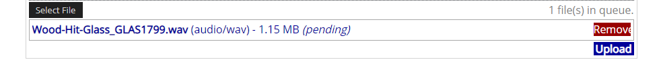
STEP THREE:
Once the files are uploaded the screen will change to show you details about all the files.
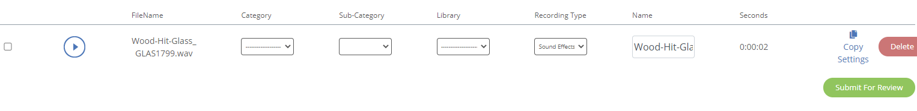
The playback button is live and you can listen to any file if you need to. You can use the Delete button on any line to delete a file if you do not want to continue with adding it to SoundDogs.com.
You do not have to include all of the metadata information at this stage, but you must include the Category and the Library or you will not be able to proceed with your Upload. Only your existing Libraries will show up in the Library dropdown list. Once you select a Category for a track, only the related Sub-Categories will appear in the dropdown list.
If all of your tracks have the same Category, Sub-Category, Library, Recording Type you can fill in the first record, select all records and double-click the blue Copy Settings link to the right of the first record. You will see that the Recording Type defaults to Sound Effects so take care if you are adding music.
When you are sure that you want to upload these files and that the Category and Library information is in place, click the green Submit for Review button at the bottom of the list. You will be asked to confirm that you want to continue with the upload. Click OK to continue.
STEP FOUR:
From the confirmation screen, use the green button to download the metadata template that has been created for your uploaded sounds. Fill in all of the data and submit the template by email to SoundDogs.com to accompany your upload. Your new sounds will not be added if SoundDogs does not receive this completed template.
The metadata template is an Excel file. Do not change the name of this file. Its name is directly related to an ID number given to your batch upload.

STEP 5:
Open the Excel file you downloaded. It is protected and to make changes you need to remove the protection. First, open the REVIEW tab and click the “Unprotect Sheet” option to release the protection. When you click Unprotect it changes to “Protect Sheet” like the image below. You will now be able to edit the metadata template you downloaded.
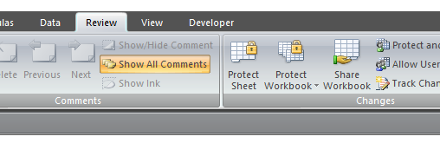
COLUMNS IN THE METADATA TEMPLATE
Do not change the information in the first 3 columns: ID, PublisherUploadID or Filename. These columns are necessary to match the metadata to the files you uploaded. To give all of your content the best possible chance of being found, previewed and purchased by SoundDogs.com user all columns are required. Any data (Library, Category, Sub-Category etc) you added during the Upload session will already be in the metadata template you download.

Category: this must be one of the Sound Effects or Music Categories available on SoundDogs.com. A sound that is not categorized will not be approved for upload to the site. See the resource list section at the end of this document for links to download current lists of available codes.

Sub Category: this must be one of the Sub Categories related to the Category you picked above. A sound that is not Sub categorized will not be approved for upload to the site. See the resource list section at the end of this document for links to download current lists of available codes.
Name: This is the information you want to display on the search results page. Here are some good examples:
Sound Effect Example – what you include in the Name column is what advertises the sound and is valuable for the search engine. The library name is added automatically by the system.
Music Track Example – This can include information about the version (full, alt, 60, 30, sting), a description of the music, the bpm or instrumentation if you would like, the composer and publisher details. The library name is added automatically by the system.
Description: This is information that is not displayed on the site but can be used as search phrases separated by commas. As many as four phrases are allowed.
Keywords: These are single words, separated by commas. As many as ten words are allowed.
Bit Depth: the most common options here are 16, 24, 48 or 96
Sample Rate: the most common options are 44.1, 48, 96 or 192
Channels: 1, 2, 4, 5 - note that if you are uploading a multi-channel track with more than 5 channels, the preview file will not be automatically made. You need to notify us and we will create the preview file manually to complete the sound upload.
Rate: this is the price you want to charge for the track. For instance five dollars and sixty cents would be entered as 5.60 and one hundred and twenty-four dollars even would be entered as 124.00. No dollar signs in this column please.
When the data is perfect, send the metadata file as an attachment to SoundDogs.com at;
support@sounddogs.com
It will be matched with your uploaded files. If there are any problems, we will contact you.
Your files will be reviewed, combined with your datafile, approved and added to SoundDogs.com.
We will send you an email to confirm the process when it is done.
RESOURCES TO DOWNLOAD
A complete list of Sound Effects categories and related sub categories is available to download here:
https://www.SoundDogs.com/PublisherResources/SoundEffect-Category-SubCategory-Master-List.xlsx
A complete list of Music categories and related sub categories is available to download here:
https://www.SoundDogs.com/PublisherResources/Music-Category-SubCategory-Master-List.xlsx
Or you can look at SoundDogs.com and browse through the Category pages to see what Sub-Categories are available.
A copy of this Publisher Upload Directions document is also available for download here:
https://www.sounddogs.com/PublisherResources/Publisher-Upload-Directions.docx

